**INSTALL PYTHON**

**LATIFAH HANIF**

**L200150038**

**UNIVERSITAS MUHAMMADIYAH SURAKARTA**

**INSTALL PYTHON**

* Screenshot meng- install python 2.7.8 :

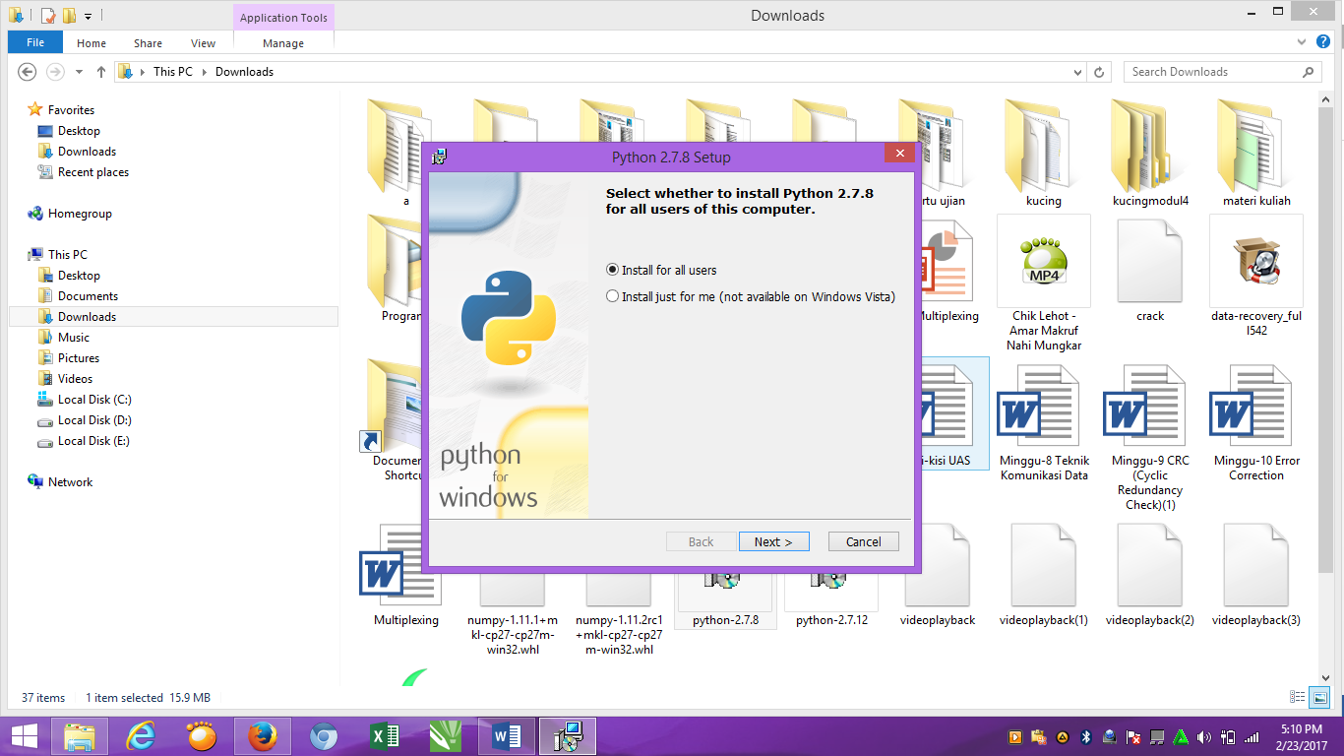

* Click “**NEXT**” :

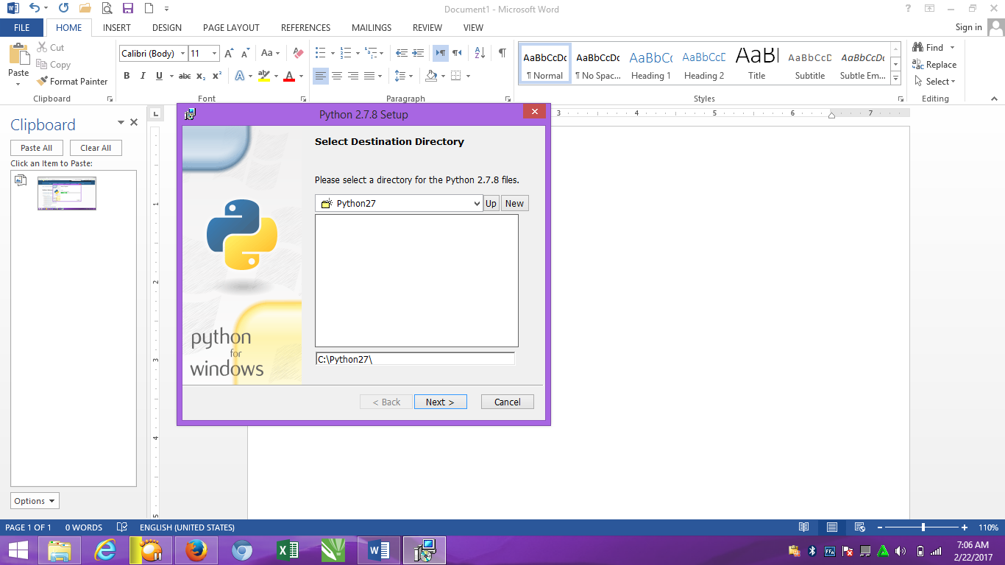

* Pilih “ **add python.exe to path** “ :

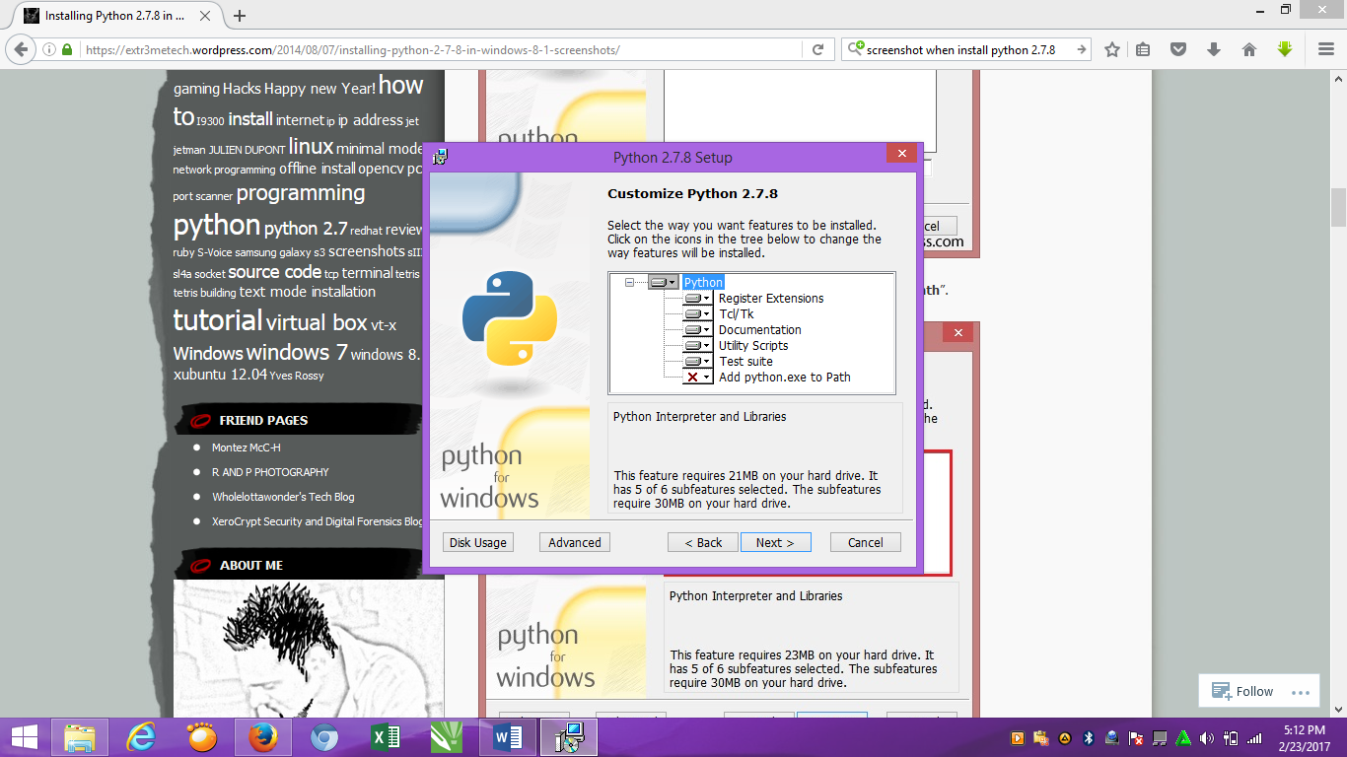

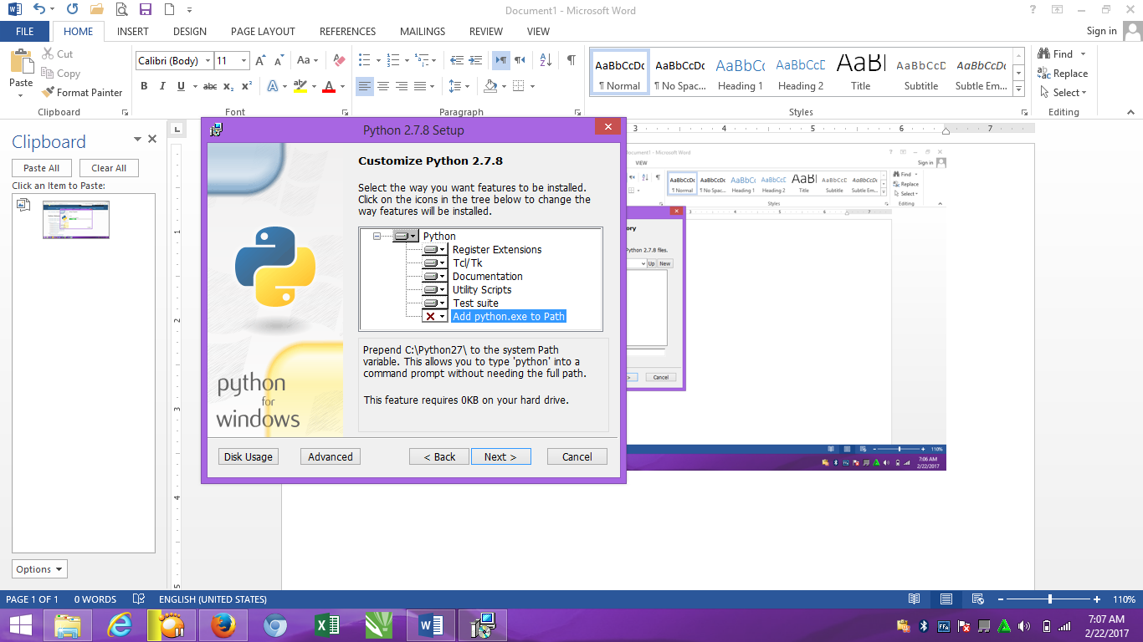

* Pilih “**Will be installed on local hard drive” :**

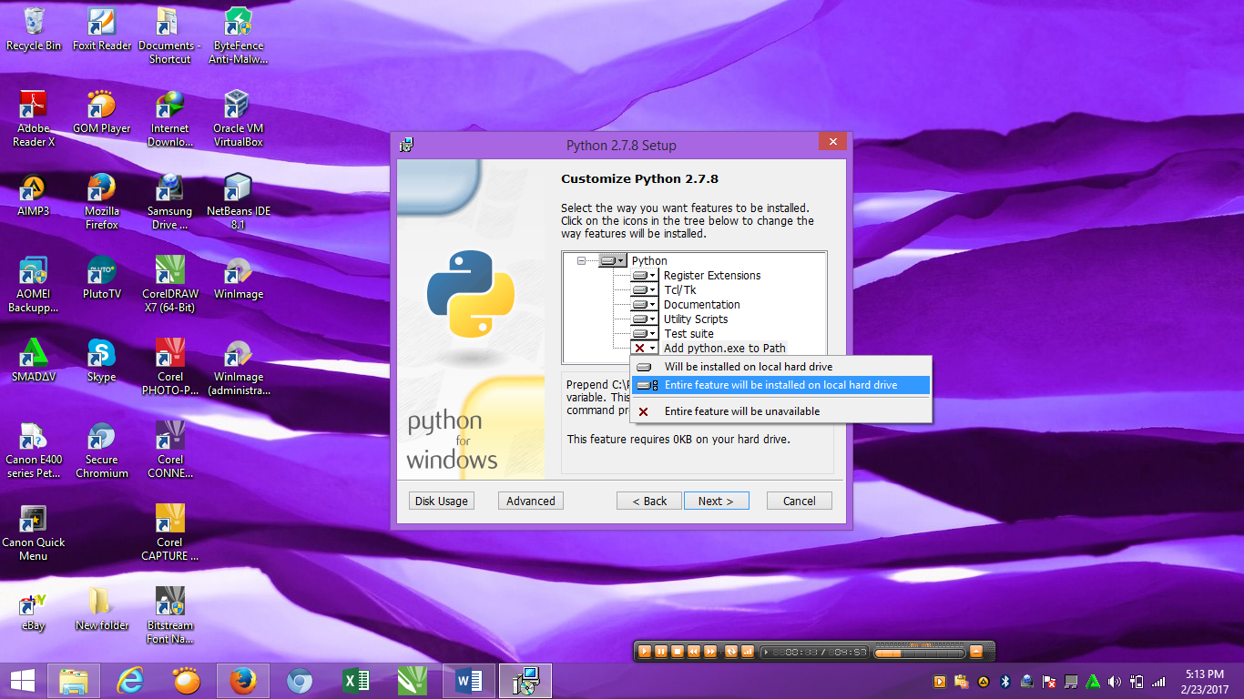

* Proses install python 2.7.8 :

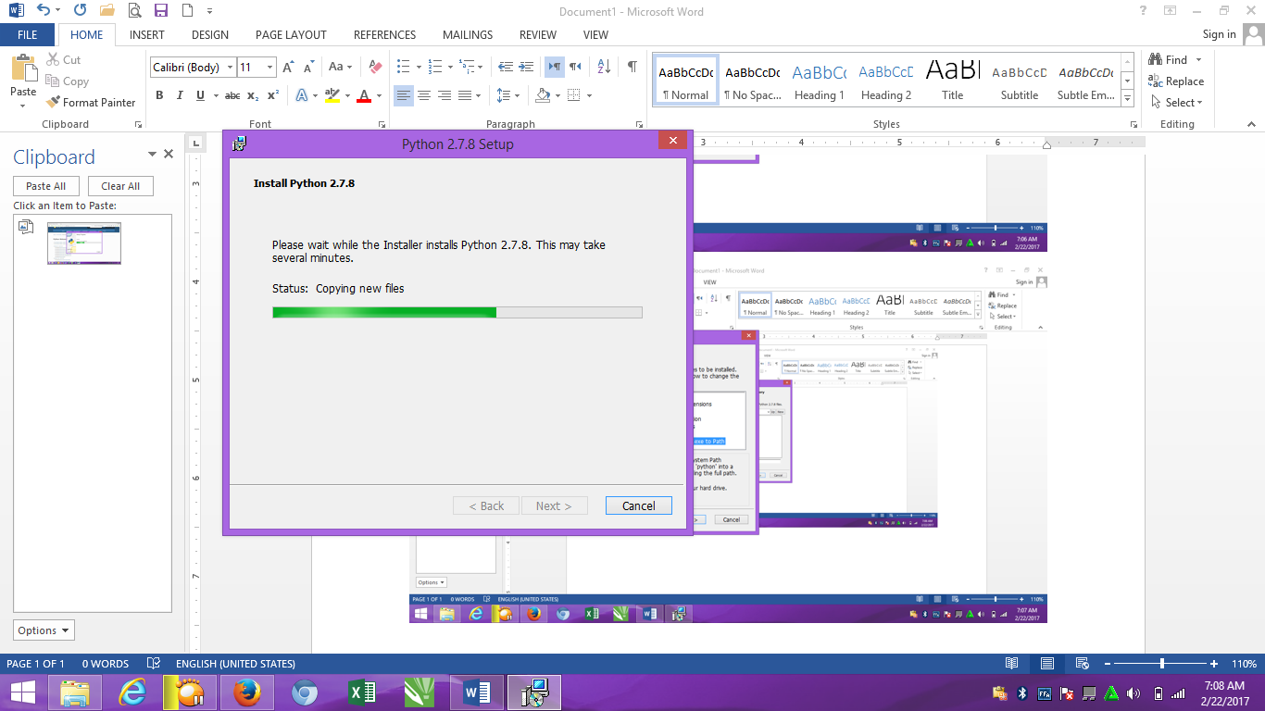

* Complete install dan click **“finish” :**

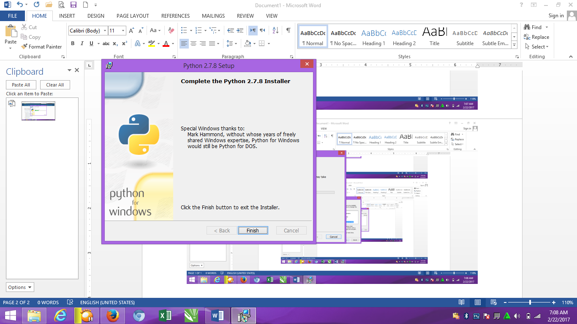

* Plilih “ **this PC** “ Kemudian click “**propertices” :**
* Pilih **“ advanced system settings “:**

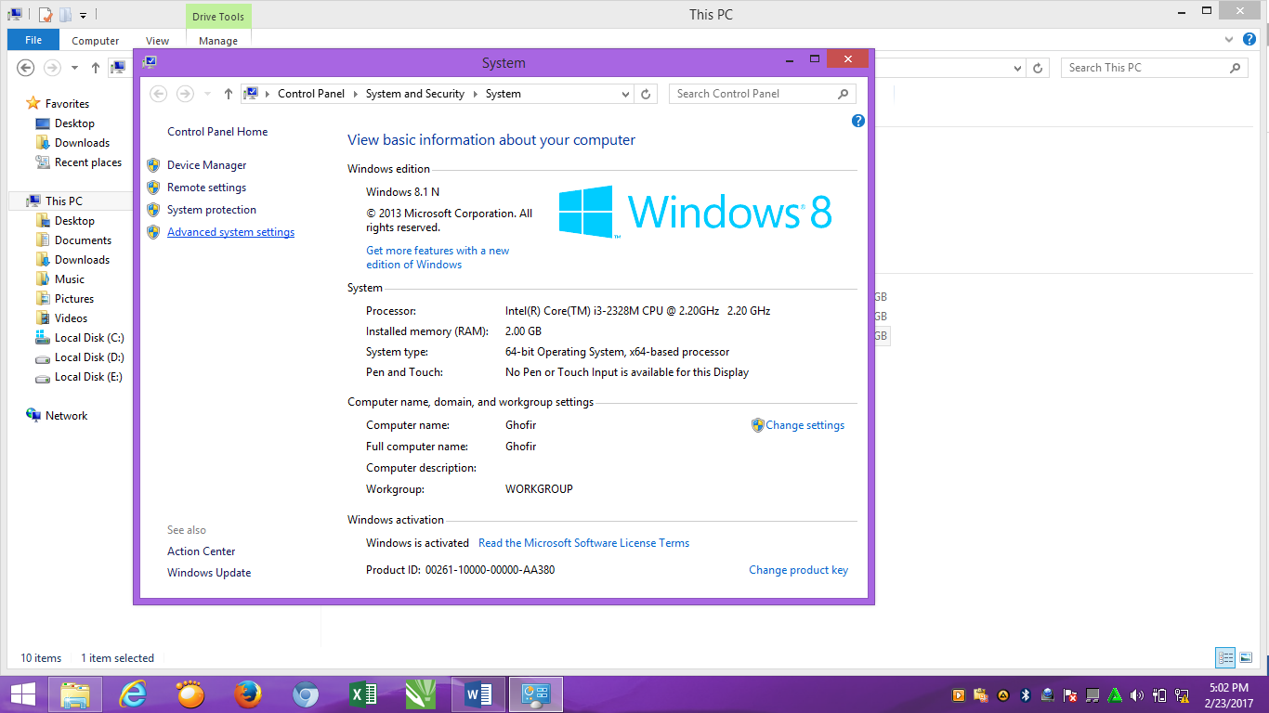

* Pilih “ **Enviorment Variables “ :**

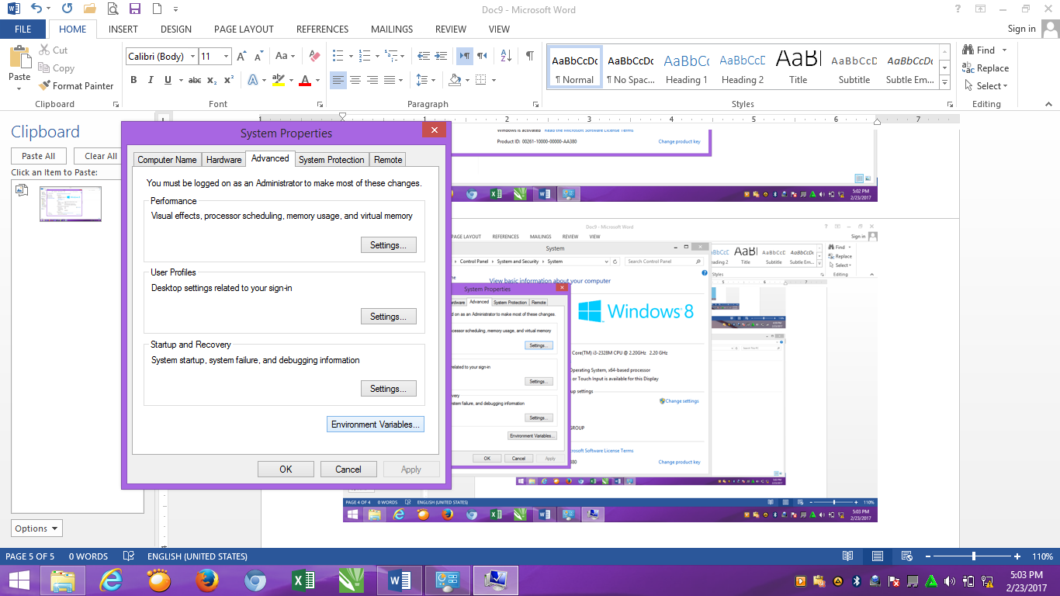

* Ganti pada “**system variables “** pada path “ C:\Python27\;C:\Python27\Scripts;C:\Python27\Lib ”

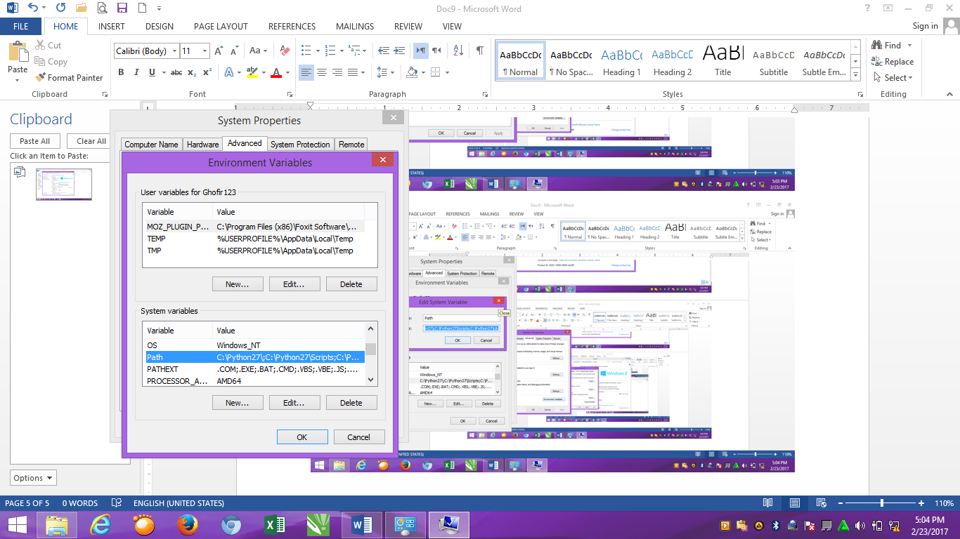

* Setelah diedit “C:\Python27\;C:\Python27\Scripts;C:\Python27\Lib “
* Click **“ok” :**

